1. **Git push in github**

Description: Push all file in master branch

**Command:** git push origin master

**Task:**

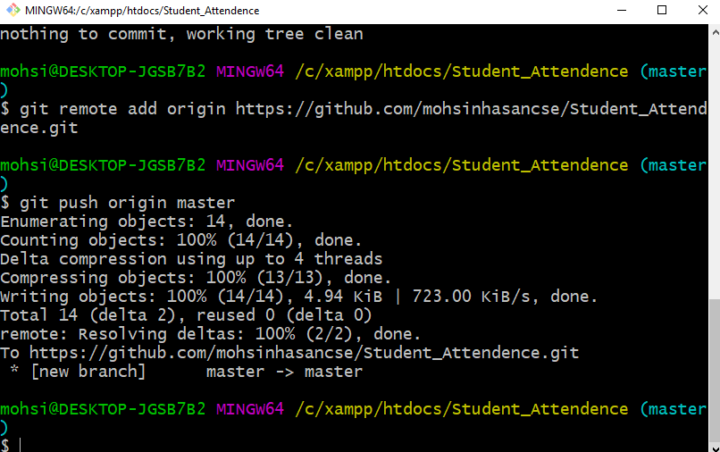

1. **Create folder using command**

Description: To create a new folder

**Command:** mkdir [folder name]

Task:

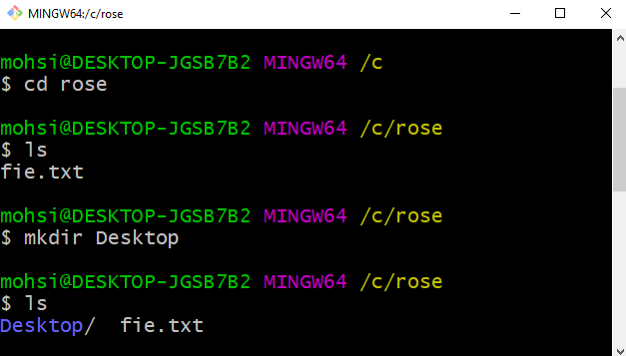

1. **Delete folder using command**

Description: Delete a folder

**Command:** rmdir [folder name]

Task:

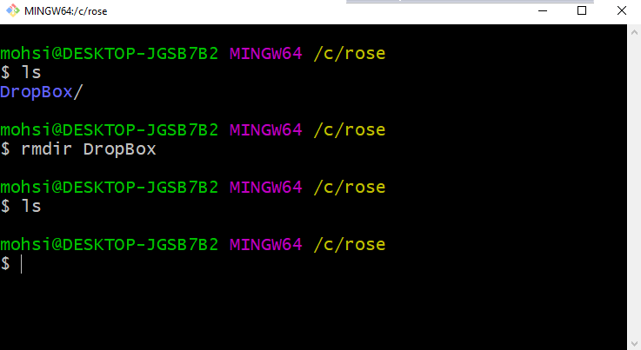

**4.Create file and write using command**

**Command:** cat > filename.txt

**Task:**

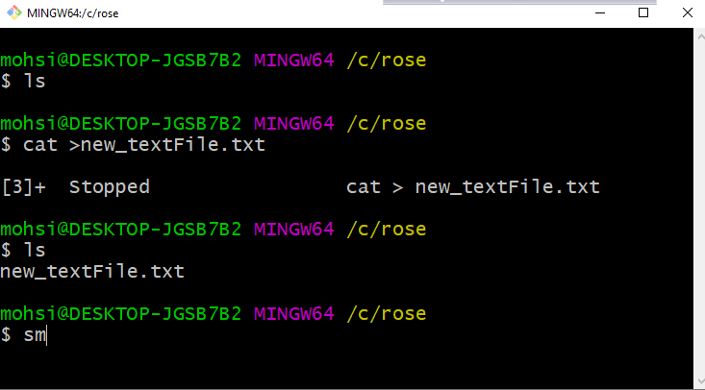

**5.Change status**

Description: View Change

**Command:** git log

**Task:**

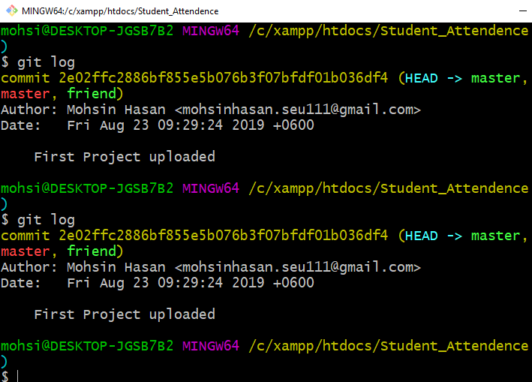

**6.Commit**

Description: Commit Changes

**Command**: git commit -m “commit message”

**Task**:

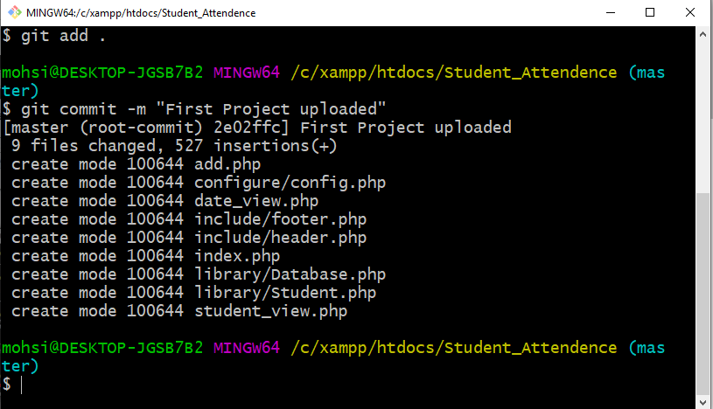

**7.Initialize**

Description: Initialize a local git repository

**Command:** git init

**Task:**

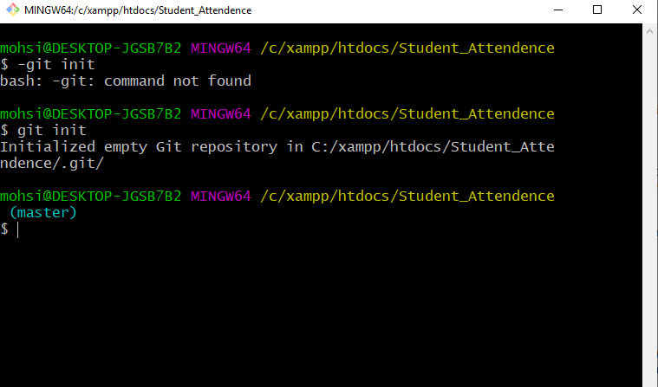

**8.New branch**

Description: Create a new Branch

**Command:** git branch [branch name]

**Task:**

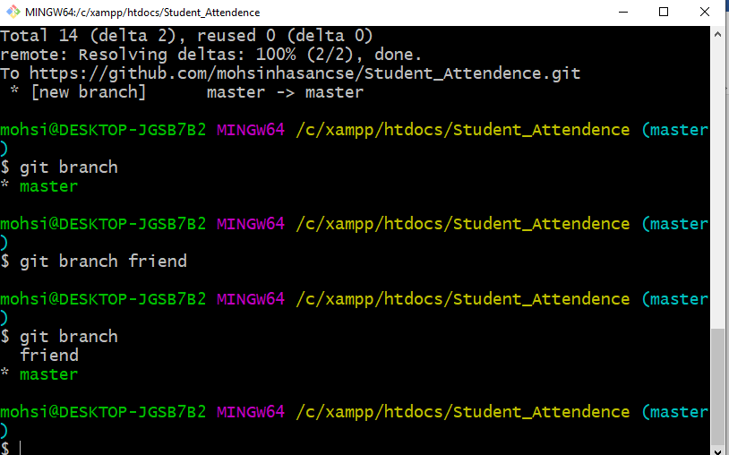

**9.Git Add**

Description: Add all new and Changed file to staging area

**Command:** git add .

**Task:**

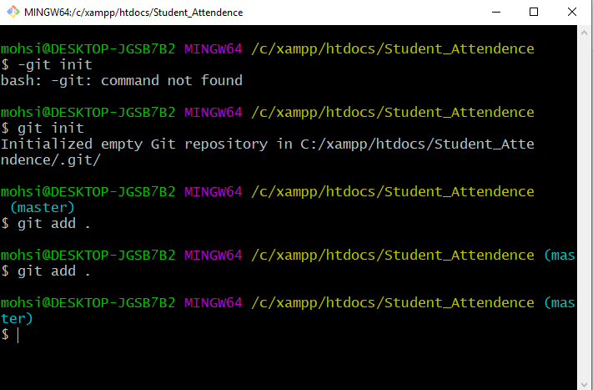

**10.Status**

Description: Check Status

**Command:** git status

Task:

